0

# Lab #3

# Setting up A SOHO network

# Week #4/5

# NACT-262 Fundamentals of System Administration

# 2025-2026 Fall Semester

# Submitted by Jibreal Id-deen

# Due by September 28, 2025

# Professor Mark Jeremy

Table Of Contents

Objective 3

Network DIAGRAM 4

Procedure 7

Questions and Answers 99

Observations 100

Table of Figures

Figure 1 - Type the router's login website 12

Figure 2 - Click here to procced 12

Figure 3 - Click "next" 13

Figure 4 - Set the new password 13

Figure 5 - Firmware Updating 14

Figure 6 - Log in the router Account 15

Figure 7 - The Overview of the router dashboard 15

Figure 8 - Click "Basic" then "Internet" 16

Figure 9 - Check the router's WAN IP Address 17

Figure 10 - Click "LAN Setup" 18

Figure 11 - Check the Router's LAN IP to change 19

Figure 12 - Done changing the LAN IP Address 20

Figure 13 - Disable the DHCP Server 20

Figure 14 - Apply it 21

Figure 15 - Click "Wireless" 22

Figure 16 - Disable Wi-Fi (2.4GHz) 23

Figure 17 - Disable Wi-Fi (5GHZ) 23

Figure 18 - Apply it 23

Figure 19 - Type "Control Panel" to enter 24

Figure 20 - Follow the process to Network Connections 24

Figure 21 - Click this "Ethernet" 24

Figure 22 - Click "Properties" 25

Figure 23 - Put the manually IP address and the required stuffs on it 26

Figure 24 - Type "ipconfig" on Desktop PC and see the rest of the ethernet adapter 27

[Figure 25 - Click "Router Status" then click "Set Password" 28](https://rit0-my.sharepoint.com/personal/cai5656_rit_edu/Documents/FSA/Iddeen_J_Lab_2_IPMI_and_Microsoft_Window_Server.docx#_Toc209719016)

Figure 26 - Set new password and confirm it 29

Figure 27 - Connect to iDRAC and NIC 1 with ethernet from the router 30

Figure 28 - Make sure to remember the bench number for IP Address 31

Figure 29 - in iDRAC setting, click "System BIOS" 31

Figure 30 - Click "Network" 32

Figure 31 - Put the manually IP address and the required stuff on it 32

Figure 32 - Open the VMware Workstation pro 33

Figure 33 – Procced 34

Figure 34 - Make sure to select the Windows Server 2019 to be detected 35

Figure 35 - Select WS 2019 Standard for VM 36

Figure 36 - Click "Edit" 37

Figure 37 - Click "Virtual Network Editor" 38

Figure 38 - Click "Change Settings" 39

Figure 39 - Change the VMnet information to bridge to the ethernet controller 40

Figure 40 - Reboot into Windows Server 2019 41

Figure 41 - Open the control panel 42

Figure 42 - Click the "Network and Internet" 42

Figure 43 - Click "Ethernet0" 43

Figure 44 - Click "Properties" 44

Figure 45 - Click this IPv4 45

Figure 46 - put the manually IP address and the required stuff on it 46

Figure 47 - Open the Server Manager then click "Local Server” 47

Figure 48 - Change the computer name 47

Figure 49 - Done changing computer name 48

Figure 50 - Click Manage 48

Figure 51 - Click " Add Roles and Features" 49

Figure 52 - Proceed! 49

Figure 53 - Click "Web Server (IIS)" 50

Figure 54 - Click "Add Features" 51

Figure 55 - Install the Web Server Role 52

Figure 56 - Installation started 53

Figure 57 - Installation successfully 53

Figure 58 - Open Notepad 54

Figure 59 - Make an html coding on notepad 54

Figure 60 - Click "Save As" 55

Figure 61 - Type the required file name to put in 55

Figure 62 - Type "Rufus" and click this link 55

Figure 63 - Download rufus.exe 56

Figure 64 - Copying ISO files 56

Figure 65 - Ready to go! 56

Figure 66 - Install windows Server 2019 in PC-B 57

Figure 67 - click this WS 2019 Standard 57

Figure 68 - Installing Windows 58

Figure 69 - Loading files 58

Figure 70 - Change the computer name by pressing two number 59

Figure 71 - Done changing the computer name 59

Figure 72 - Type "sconfig" 59

Figure 73 - Change the IP Address and put the required stuffs on it 60

Figure 74 - Set the new DNS Server 60

Figure 75 - Use PowerShell as command then type the required command 61

Figure 76 - Type the HTML language as coding to create a website and start the web service 61

Figure 77 - Install WS 2019 in the Dell Server 62

Figure 78 - Installing Windows 63

Figure 79 - The overview of the WS 2019 in Dell Server 64

Figure 80 - Click "Add roles and features" 65

Figure 81 - Select DHCP and DNS Server 66

Figure 82 - Add Features for DHCP and DNS 68

Figure 83 - Install both of it 69

Figure 84 - Installation Completed 70

Figure 85 - Click "Tools" 70

Figure 86 - Click "DNS" 71

Figure 87 - See the overview of the DNS Manager 71

Figure 88 - Add a New Zone 72

Figure 89 - Procced the Zone Wizard 73

Figure 90 - Type the required text on Zone name 74

Figure 91 - Create a new file with this file name 75

Figure 92 - Procced to complete the new Zone Wizard 77

Figure 93 - Click "Reverse Lookup Zones" to create another zone 78

Figure 94 - Procced until click "IPv4 Reverse Lookup Zone” 79

Figure 95 - Type the required network ID to procced 80

Figure 96 - Procced to do the same thing as for forward zone 82

Figure 97 - Click "finish" 83

Figure 98 - Click "New Host (A or AAAA)" 84

Figure 99 - Assign DNS A record for all of the devices 89

Figure 100 - Go back to the dashboard, and click "Tools" 89

Figure 101 - Click "DHCP" 90

Figure 102 - See the overview of the DHCP menu 91

Figure 103 - Click "new Scope" 93

Figure 104 - "Click Next" 93

Figure 105 – Procced 94

Figure 106 - Put the starting IP Address and the end to click "Next" 94

Figure 107 - set the Lease duration 95

Figure 108 - Configure DHCP Options 96

Figure 109 - Add the router Default Gateway 97

Figure 110 - Set the parent domain and edit the stuff, then click "next" 98

Figure 111 - See the Scope being Active! 98

Figure 112 - See the laptop getting IP Address from DHCP Server 99

Figure 113 - Type the IIS website on laptop 99

Figure 114 - See your own IIS website from the PCA 100

Figure 115 - Type another IIS website on the laptop 100

Figure 116 - See your own IIS Website from the PCB Core! 101

Figure 117- nslookup on DNS A and reverse IP records for router 101

Figure 118 - nslookup on DNS A and reverse IP records for PCA VM 102

Figure 119 - nslookup on DNS A and reverse IP records for PCB Core 102

Figure 120 - nslookup on DNS A and Reverse IP records for Dell Server 103

## Lab #2- IPMI and Microsoft Window Server

### Objective

As independent working on this, I set up a SOHO LAN with a router and a Windows Server 2019 providing DNS/DHCP on 192.168.2XX.0/24 and deploy IIS on PC1 and PC2, then verify site access and A/PTR DNS lookups from a wired laptop.

### Network DIAGRAM

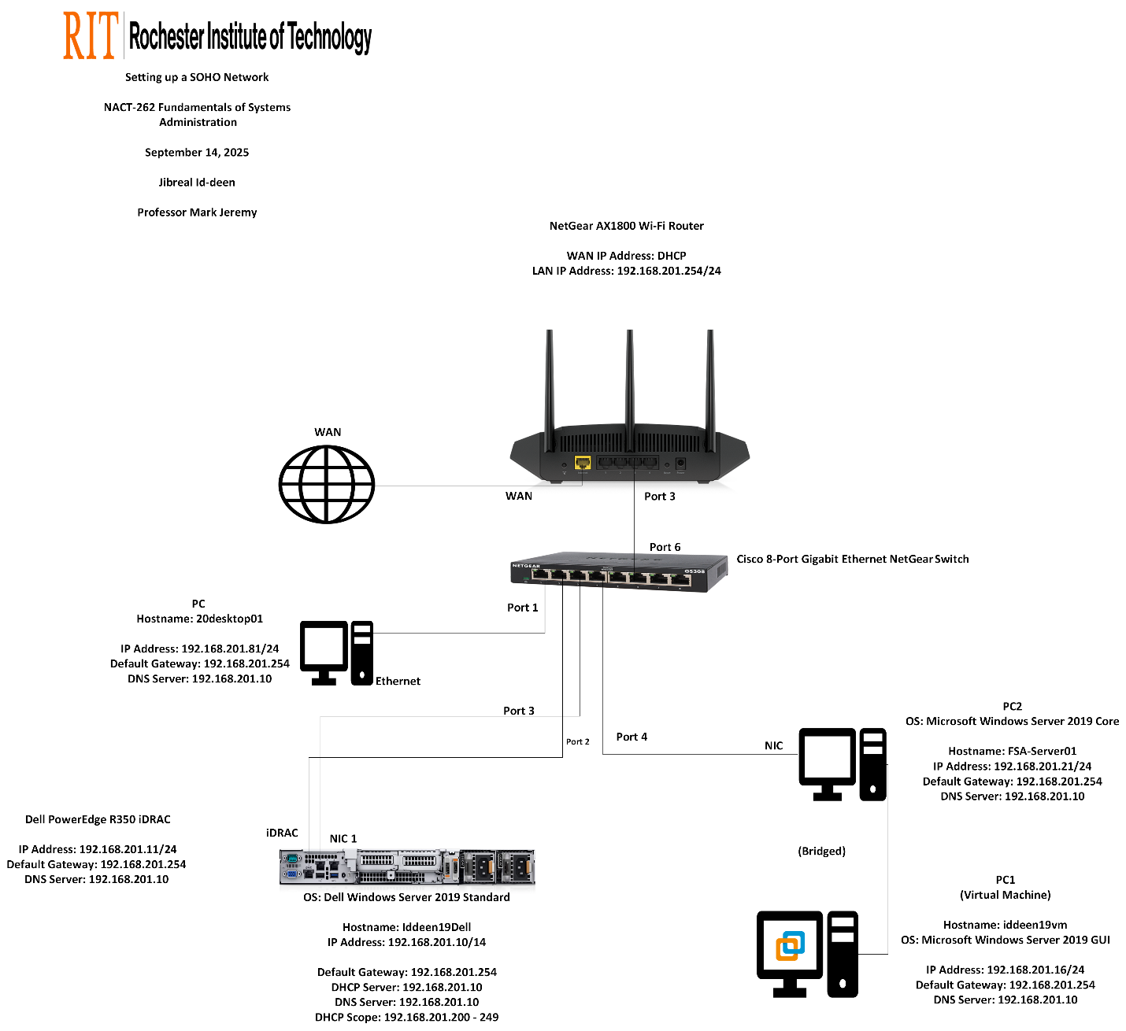

|  |  |
| --- | --- |
| Hostname | Iddeen19Dell |
| Virtual Machine or Physical? | Physical |
| Operating System | Windows Server 2019 Standard (GUI) |
| RAM size | 128GB |
| HD size | 4TB |
| IPMI IP Address (if none – remove line) | 192.168.201.11 |
| IPMI Gateway IP address (if none – remove line) | 192.168.201.254 |
| Ethernet #1 IP Address (if none – remove line) | 192.168.201.10 |
| Ethernet Gateway IP Address (if none – remove line) | 192.168.201.254 |
| Primary DNS IP Address (if none – remove line) | 192.168.201.10 |
| Network Services (if none – remove line) | DHCP Server, DNS Server |

|  |  |
| --- | --- |
| Hostname | iDRAC |
| Virtual Machine or Physical? | Physical |
| Operating System | iDRAC9 firmware |
| RAM size | 128GB |
| HD size | 4TB |
| IPMI IP Address (if none – remove line) | 192.168.201.11 |
| IPMI Gateway IP address (if none – remove line) | 192.168.201.254 |
| Primary DNS IP Address (if none – remove line) | 192.168.201.10 |
| Network Services (if none – remove line) | Remote Management |

|  |  |
| --- | --- |
| Hostname | Iddeen19vm |
| Virtual Machine or Physical? | Virtual Machine (VMware Workstation, Bridged) |
| Operating System | Windows Server 2019 Standard (GUI) |
| RAM size | 32GB |
| Ethernet #1 IP Address (if none – remove line) | 192.168.201.16 |
| Ethernet Gateway IP Address (if none – remove line) | 192.168.201.10 |
| Primary DNS IP Address (if none – remove line) | 192.168.201.10 |
| Network Services (if none – remove line) | IIS (custom homepage) |

|  |  |
| --- | --- |
| Hostname | FSA-Server01 |
| Virtual Machine or Physical? | Physical |
| Operating System | Windows Server 2019 Standard Core |
| RAM size | 32GB |
| HD size | 950GB |
| Ethernet #1 IP Address (if none – remove line) | 192.168.201.21 |
| Ethernet Gateway IP Address (if none – remove line) | 192.168.201.254 |
| Primary DNS IP Address (if none – remove line) | 192.168.201.10 |
| Network Services (if none – remove line) | IIS (custom homepage) |

### Procedure

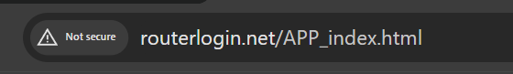

Figure 1 - Type the router's login website

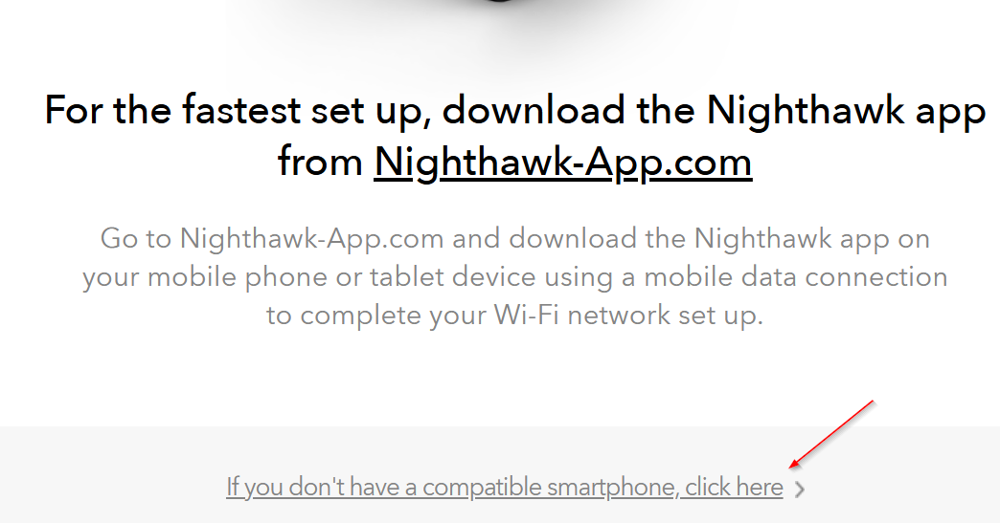

Figure 2 - Click here to procced

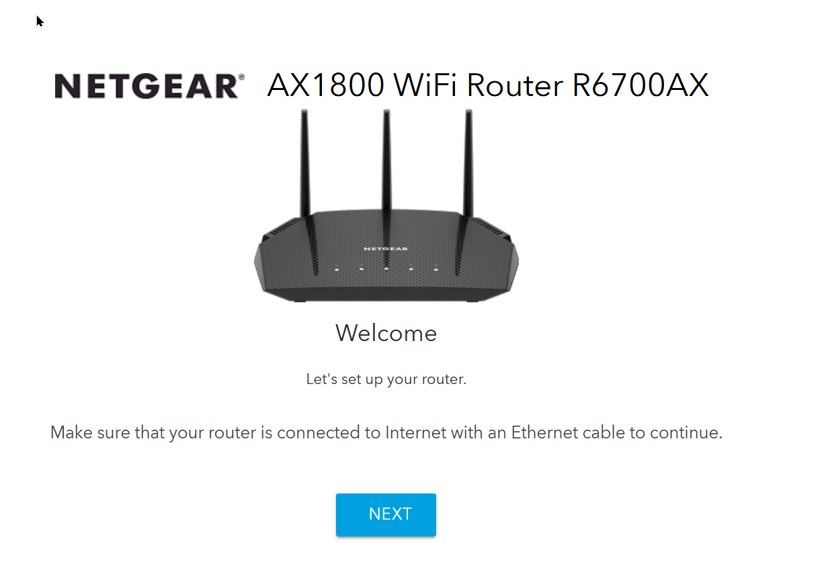

Figure 3 - Click "next"

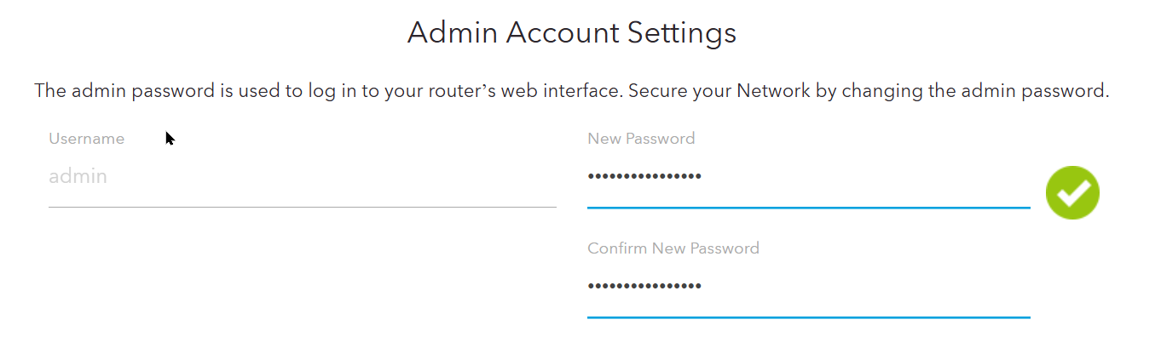

Figure 4 - Set the new password

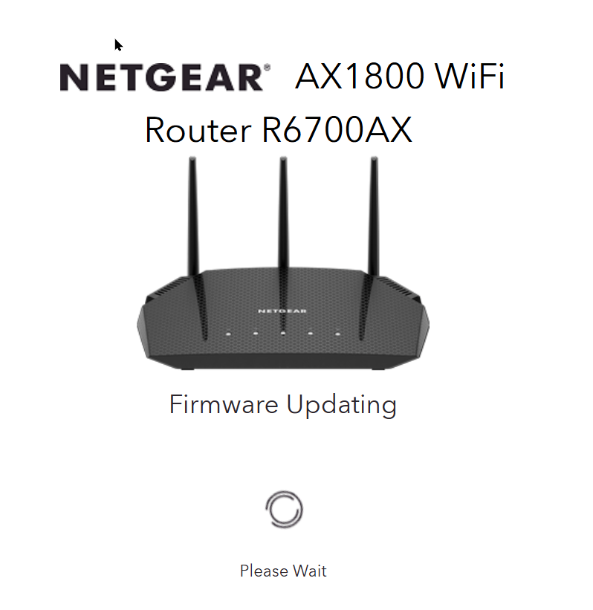

Figure 5 - Firmware Updating

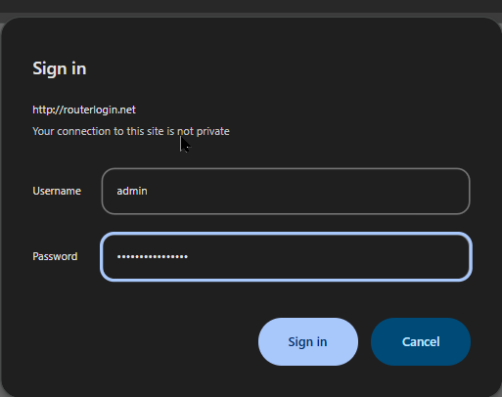

Figure 6 - Log in the router Account

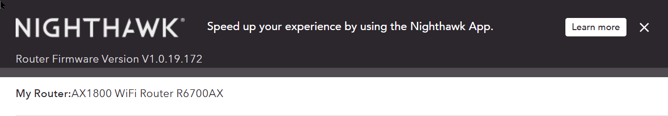

Figure 7 - The Overview of the router dashboard

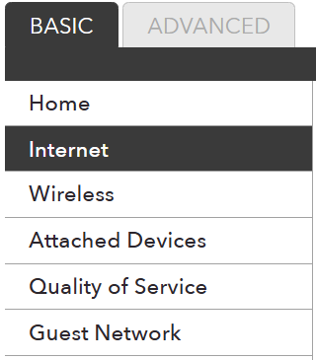

Figure 8 - Click "Basic" then "Internet"

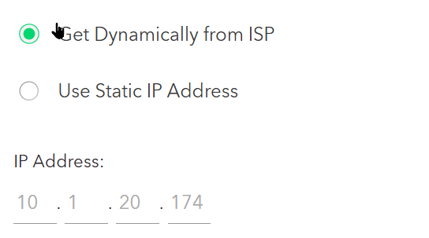

Figure 9 - Check the router's WAN IP Address

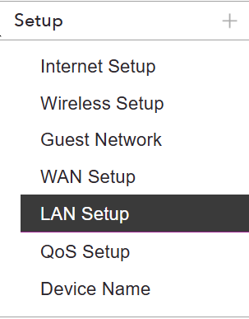

Figure 10 - Click "LAN Setup"

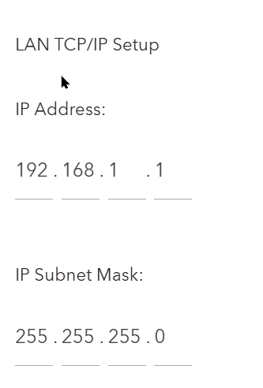

Figure 11 - Check the Router's LAN IP to change

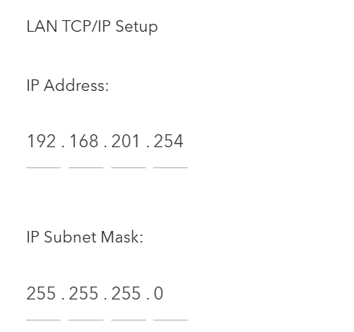

Figure 12 - Done changing the LAN IP Address

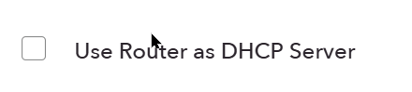

Figure 13 - Disable the DHCP Server



Figure 14 - Apply it

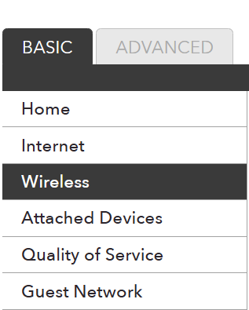

Figure 15 - Click "Wireless"

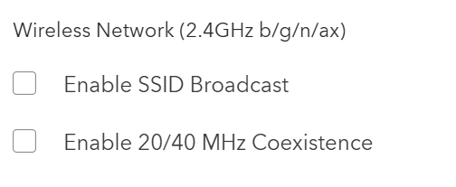

Figure 16 - Disable Wi-Fi (2.4GHz)

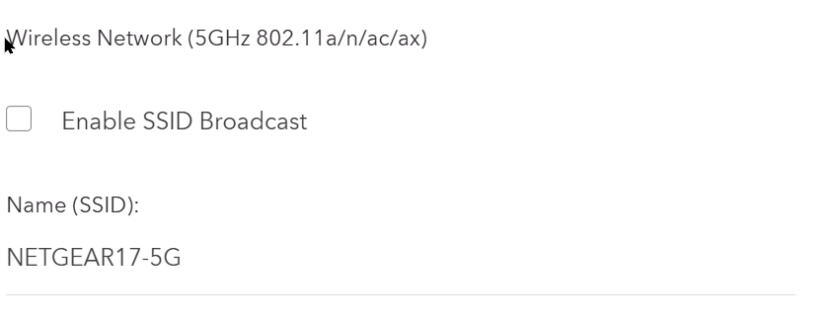

Figure 17 - Disable Wi-Fi (5GHZ)

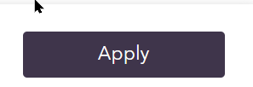

Figure 18 - Apply it

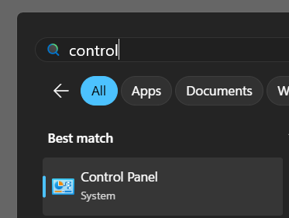

Figure 19 - Type "Control Panel" to enter

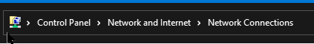

Figure 20 - Follow the process to Network Connections

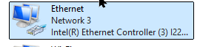

Figure 21 - Click this "Ethernet"

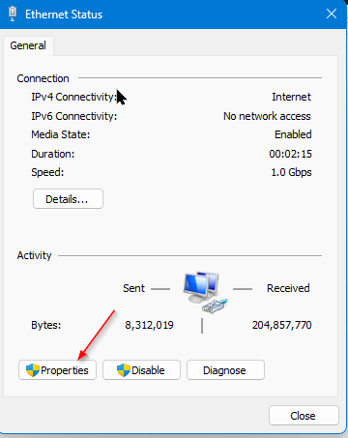

Figure 22 - Click "Properties"

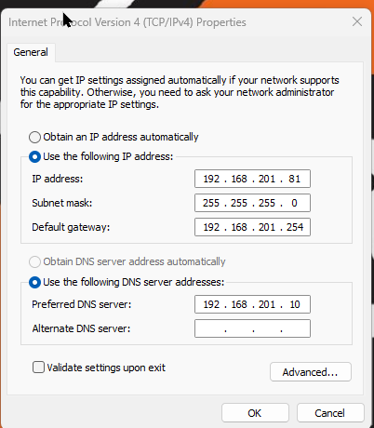

Figure 23 - Put the manually IP address and the required stuffs on it

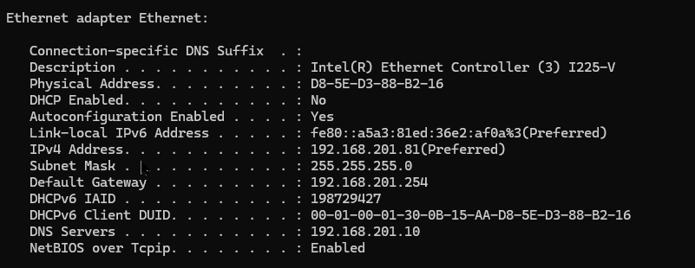

Figure 24 - Type "ipconfig" on Desktop PC and see the rest of the ethernet adapter

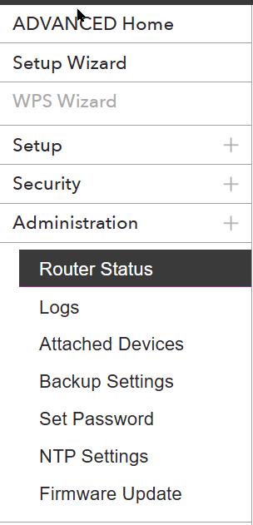

Figure 25 - Click "Router Status" then click "Set Password"

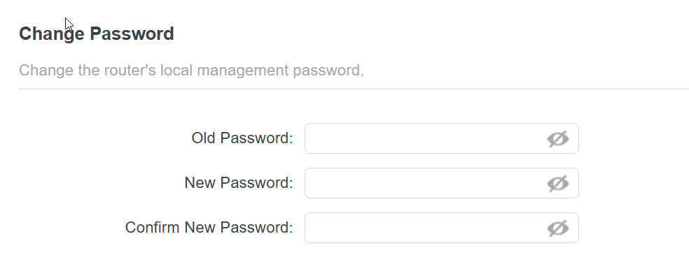

Figure 26 - Set new password and confirm it

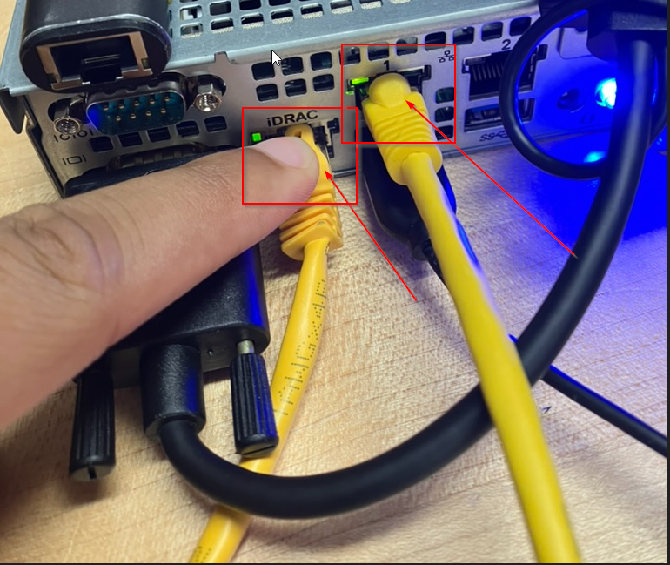

Figure 27 - Connect to iDRAC and NIC 1 with ethernet from the router

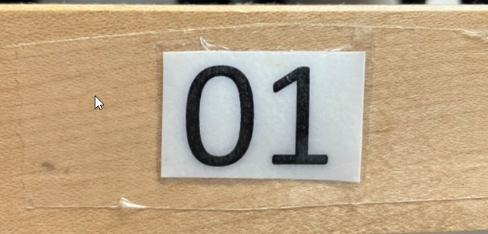

Figure 28 - Make sure to remember the bench number for IP Address

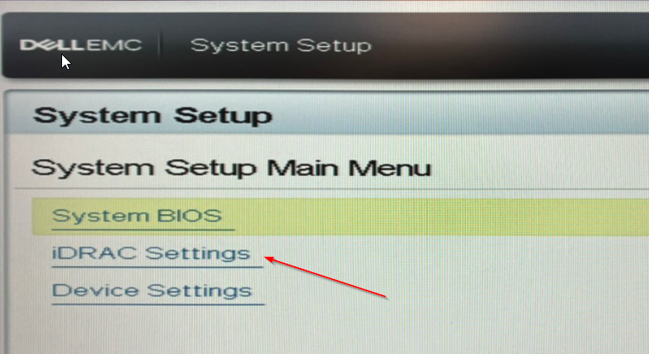

Figure 29 - in iDRAC setting, click "System BIOS"

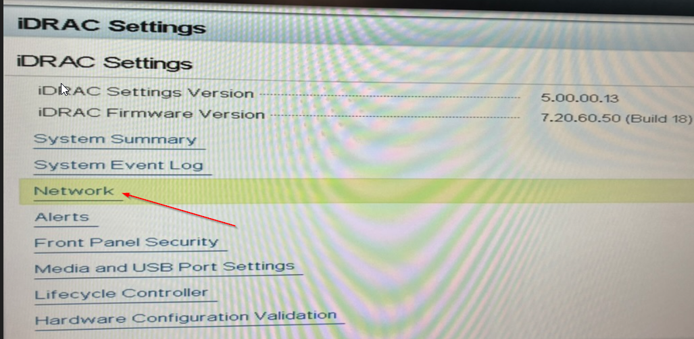

Figure 30 - Click "Network"

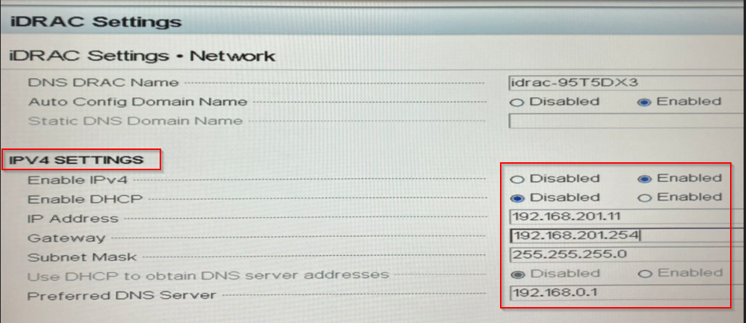

Figure 31 - Put the manually IP address and the required stuff on it

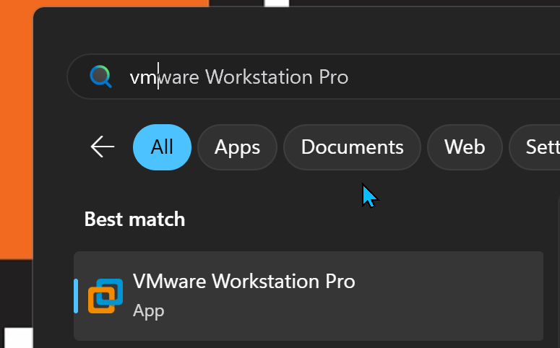

Figure 32 - Open the VMware Workstation pro

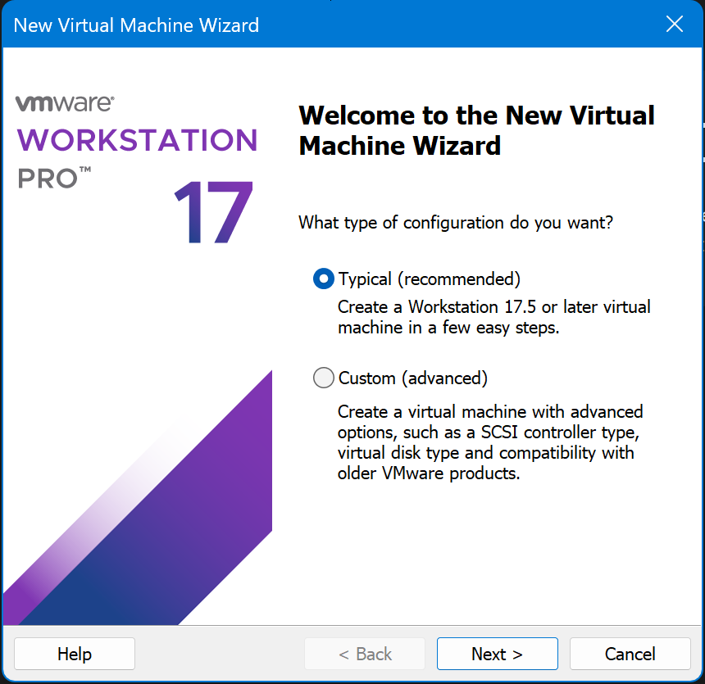

Figure 33 – Procced

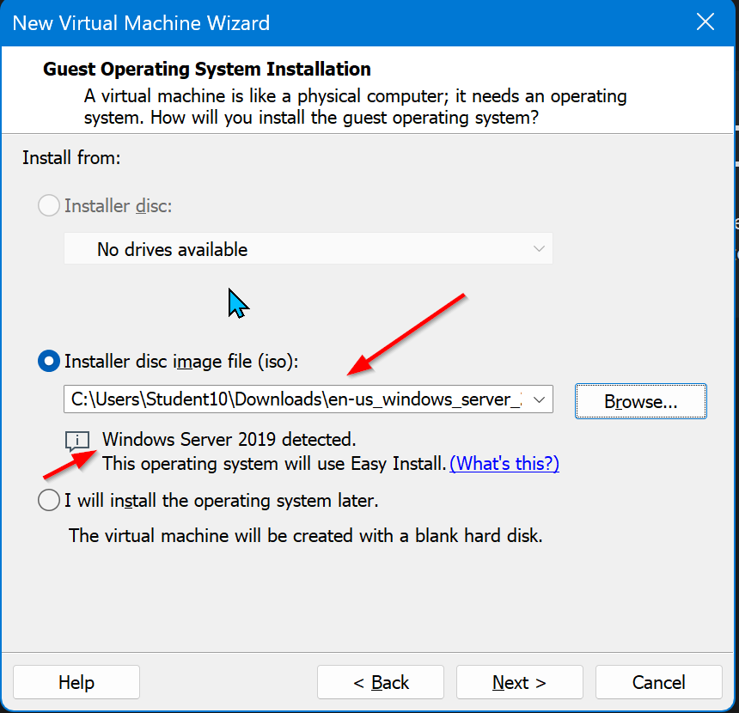

Figure 34 - Make sure to select the Windows Server 2019 to be detected

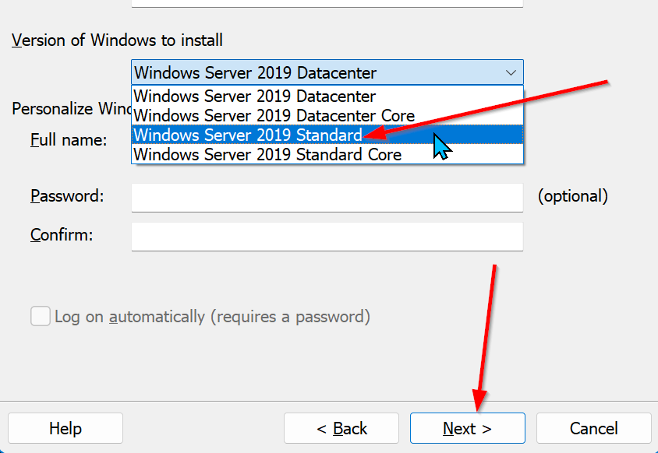

Figure 35 - Select WS 2019 Standard for VM

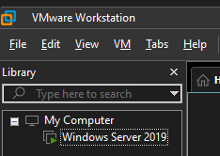

Figure 36 - Click "Edit"

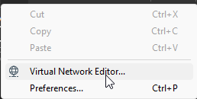

Figure 37 - Click "Virtual Network Editor"

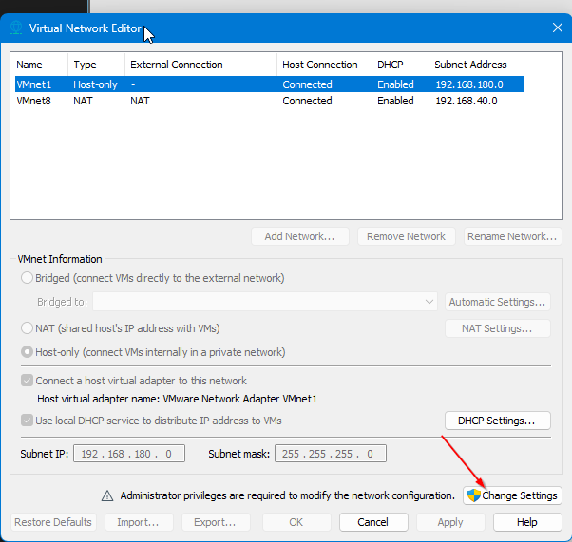

Figure 38 - Click "Change Settings"

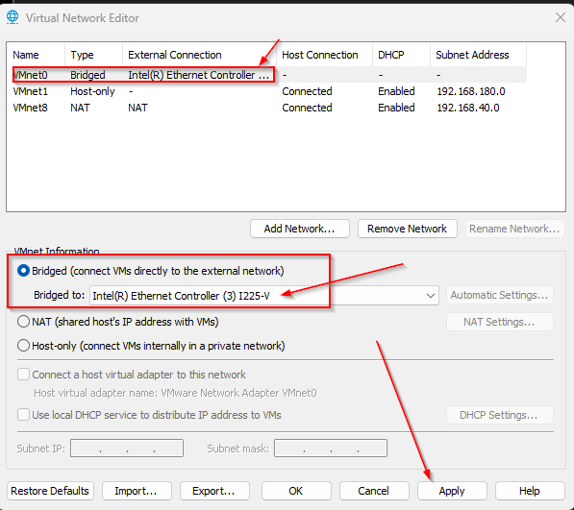

Figure 39 - Change the VMnet information to bridge to the ethernet controller

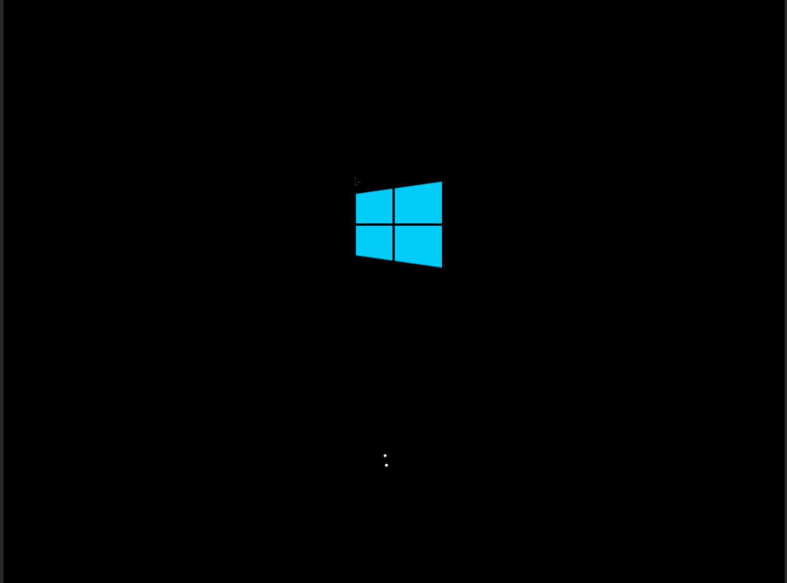

Figure 40 - Reboot into Windows Server 2019

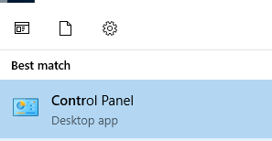

Figure 41 - Open the control panel

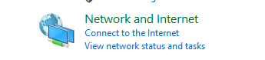

Figure 42 - Click the "Network and Internet"

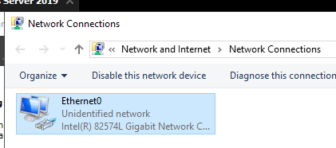

Figure 43 - Click "Ethernet0"

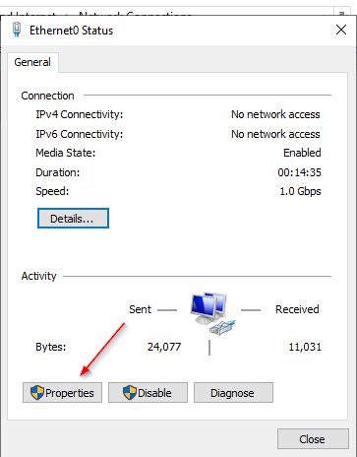

Figure 44 - Click "Properties"

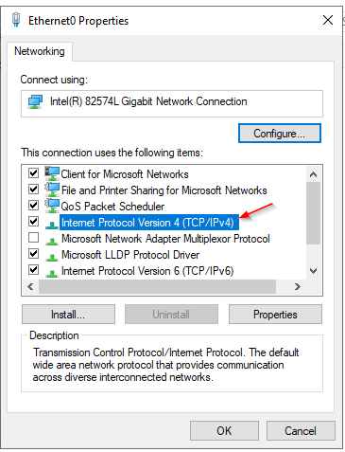

Figure 45 - Click this IPv4

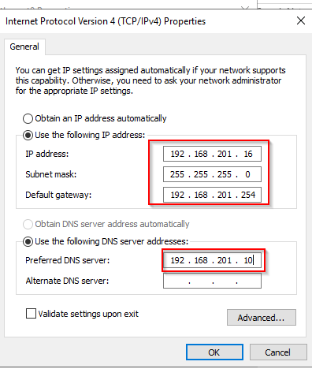

Figure 46 - put the manually IP address and the required stuff on it

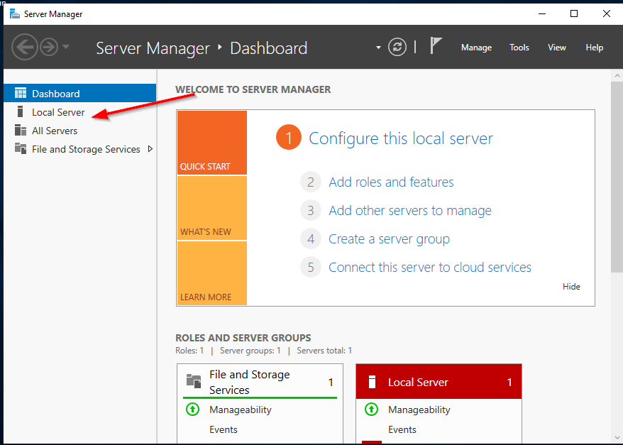

Figure 47 - Open the Server Manager then click "Local Server”

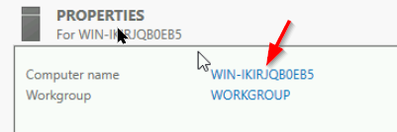

Figure 48 - Change the computer name

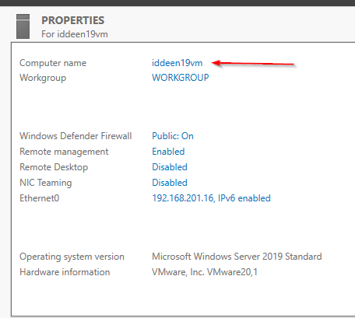

Figure 49 - Done changing computer name

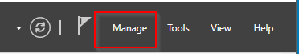

Figure 50 - Click Manage

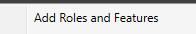

Figure 51 - Click " Add Roles and Features"

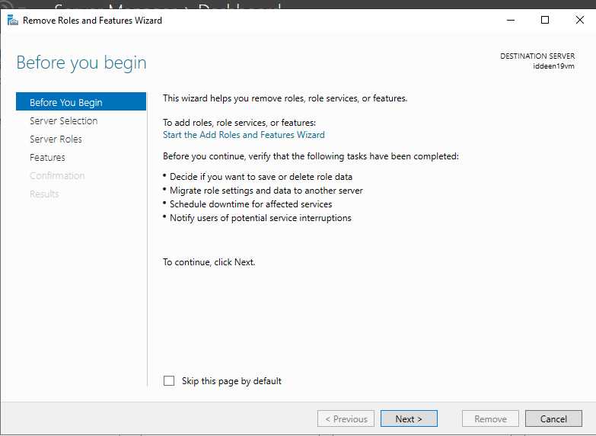

Figure 52 - Proceed!

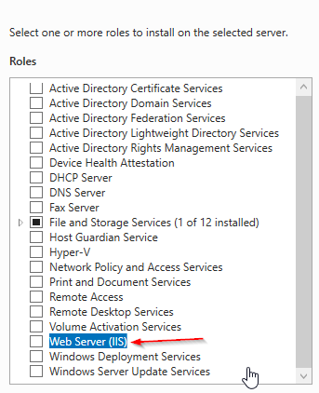

Figure 53 - Click "Web Server (IIS)"

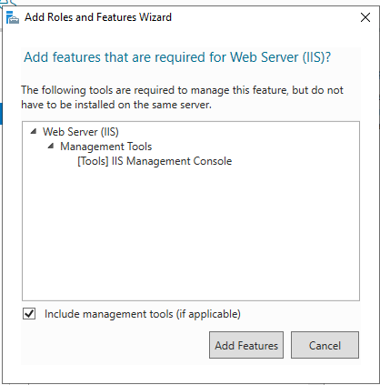

Figure 54 - Click "Add Features"

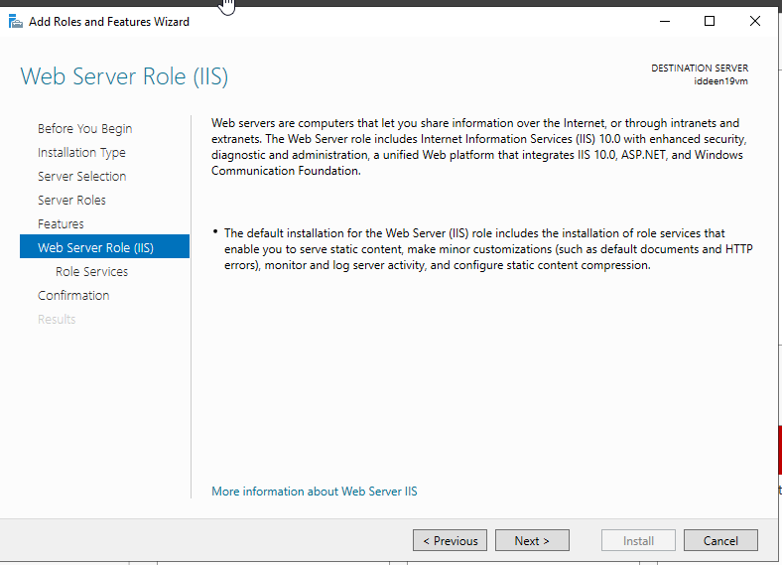

Figure 55 - Install the Web Server Role

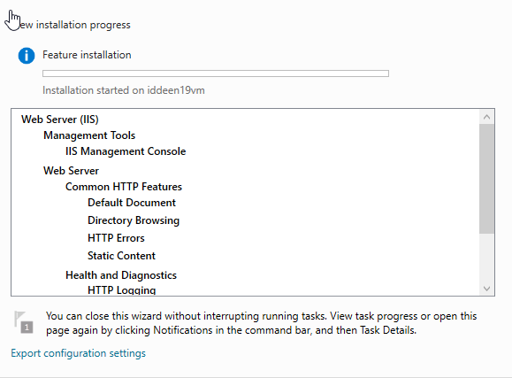

Figure 56 - Installation started

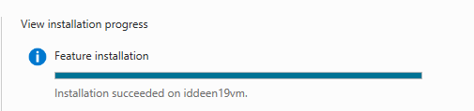

Figure 57 - Installation successfully

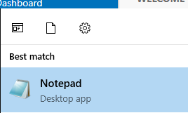

Figure 58 - Open Notepad

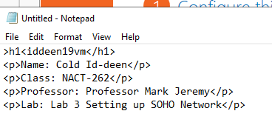

Figure 59 - Make an html coding on notepad

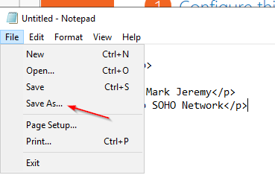

Figure 60 - Click "Save As"

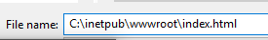

Figure 61 - Type the required file name to put in

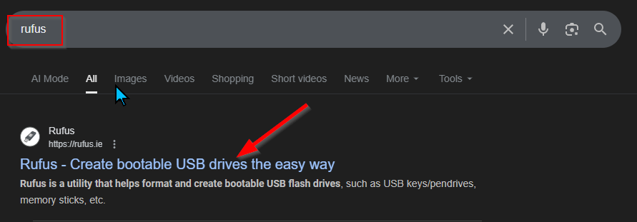

Figure 62 - Type "Rufus" and click this link

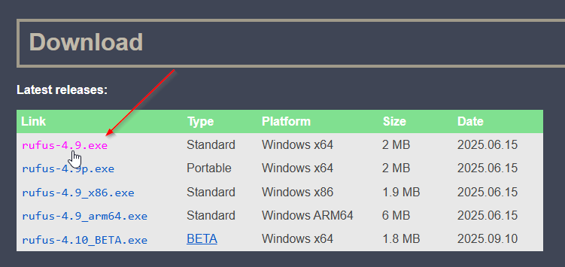

Figure 63 - Download rufus.exe

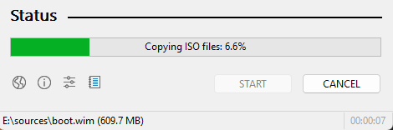

Figure 64 - Copying ISO files

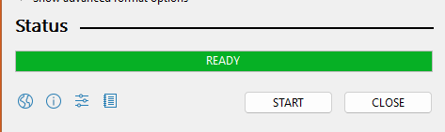

Figure 65 - Ready to go!

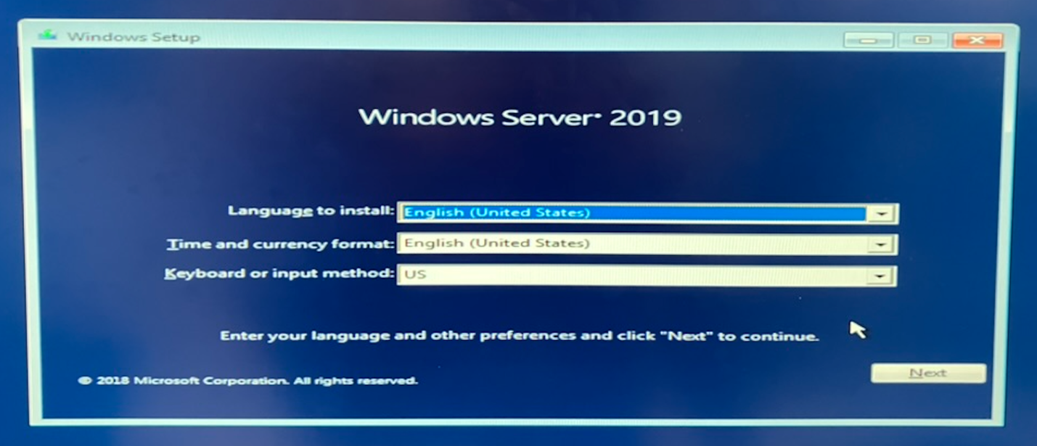

Figure 66 - Install windows Server 2019 in PC-B

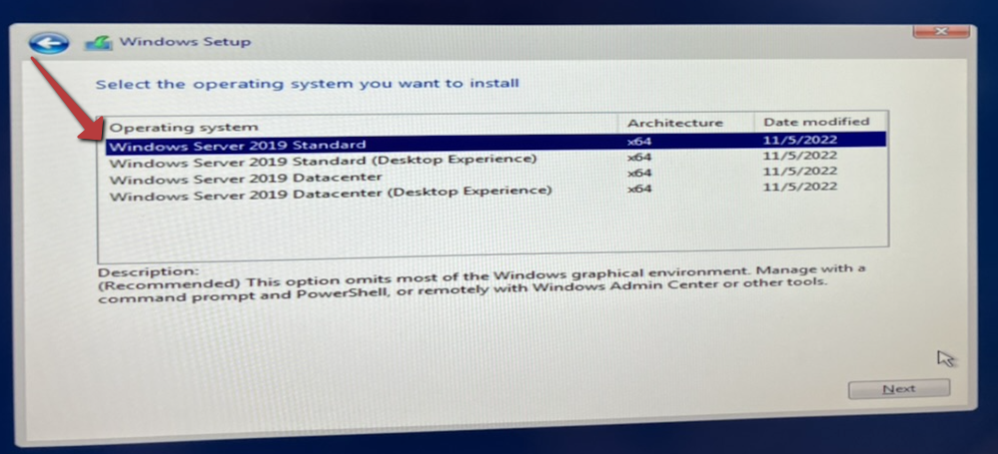

Figure 67 - click this WS 2019 Standard

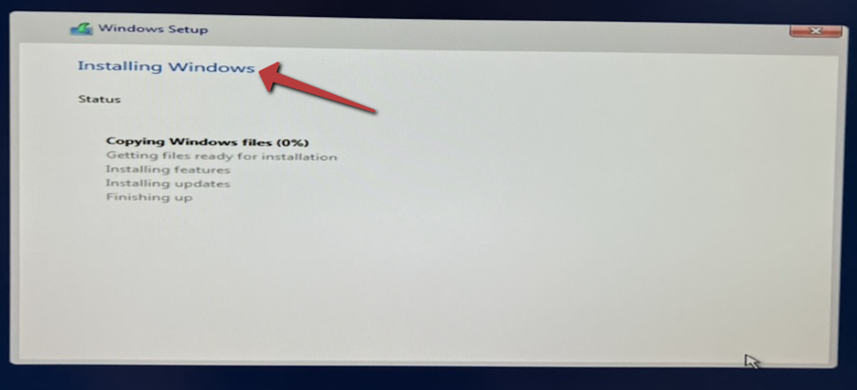

Figure 68 - Installing Windows

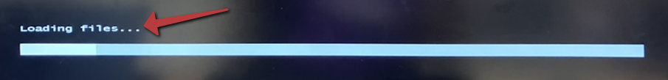

Figure 69 - Loading files

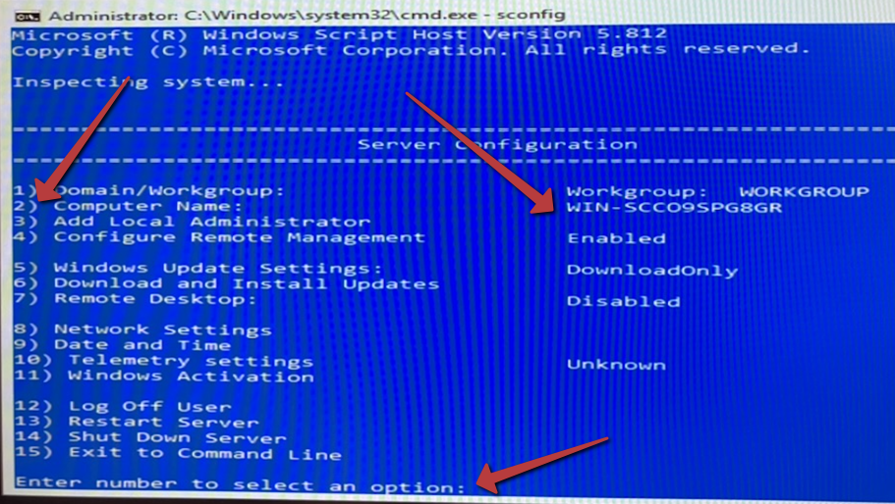

Figure 70 - Change the computer name by pressing two number

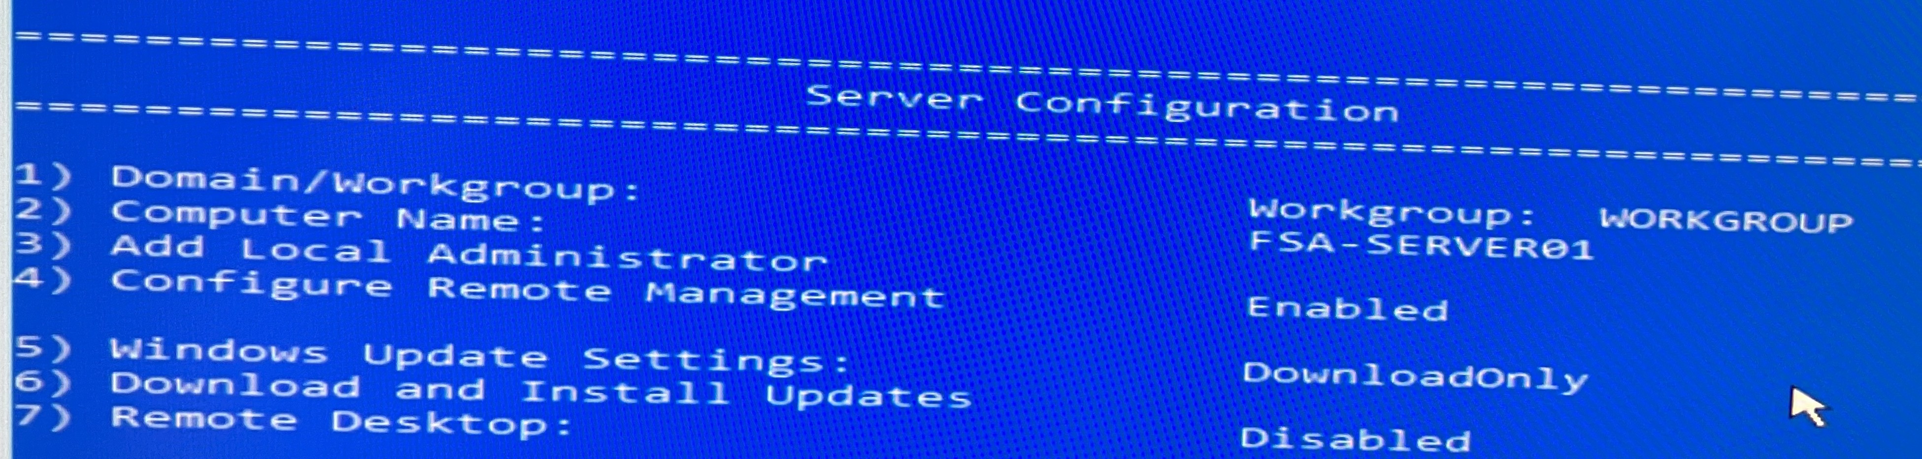

Figure 71 - Done changing the computer name

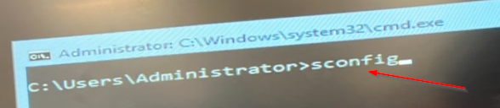

Figure 72 - Type "sconfig"

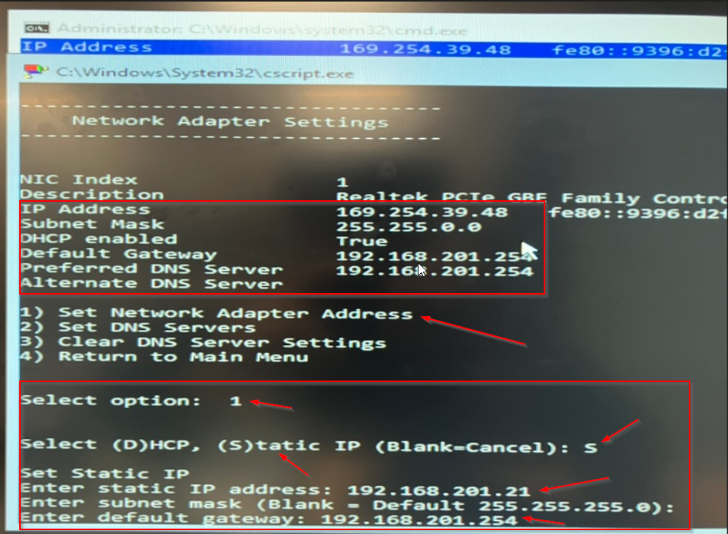

Figure 73 - Change the IP Address and put the required stuffs on it

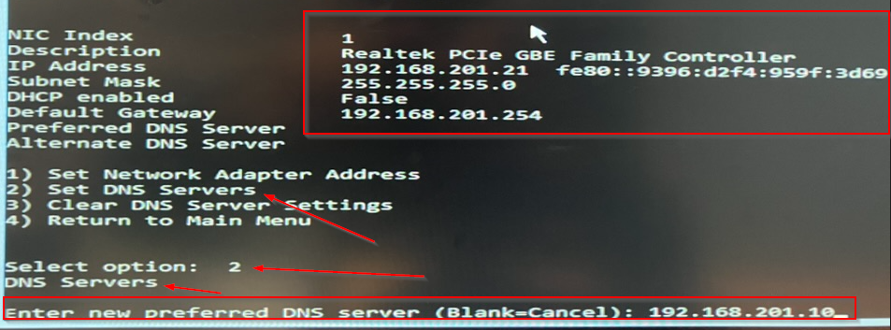

Figure 74 - Set the new DNS Server

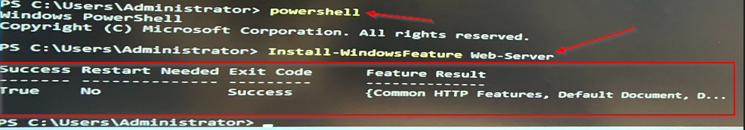

Figure 75 - Use PowerShell as command then type the required command

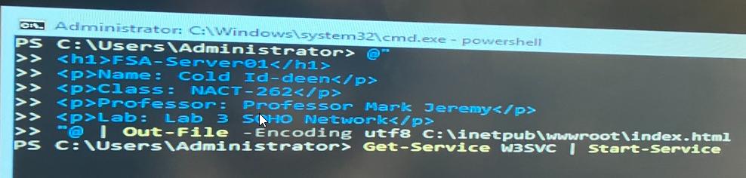

Figure 76 - Type the HTML language as coding to create a website and start the web service

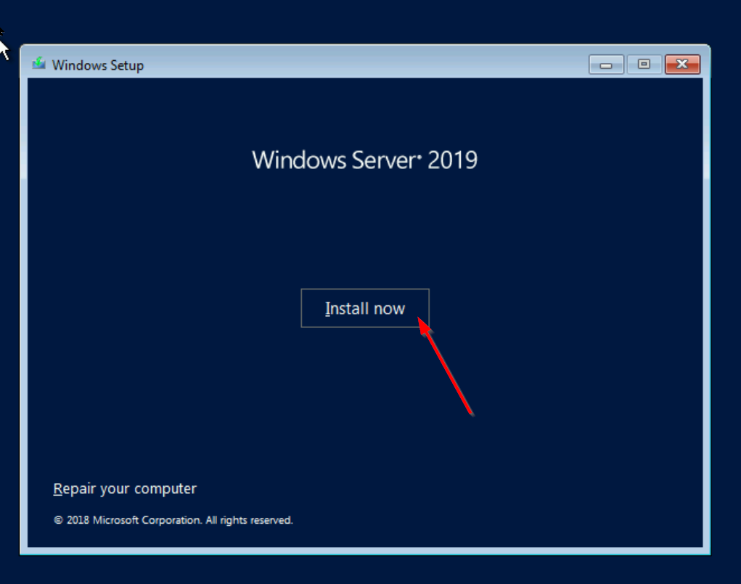

Figure 77 - Install WS 2019 in the Dell Server

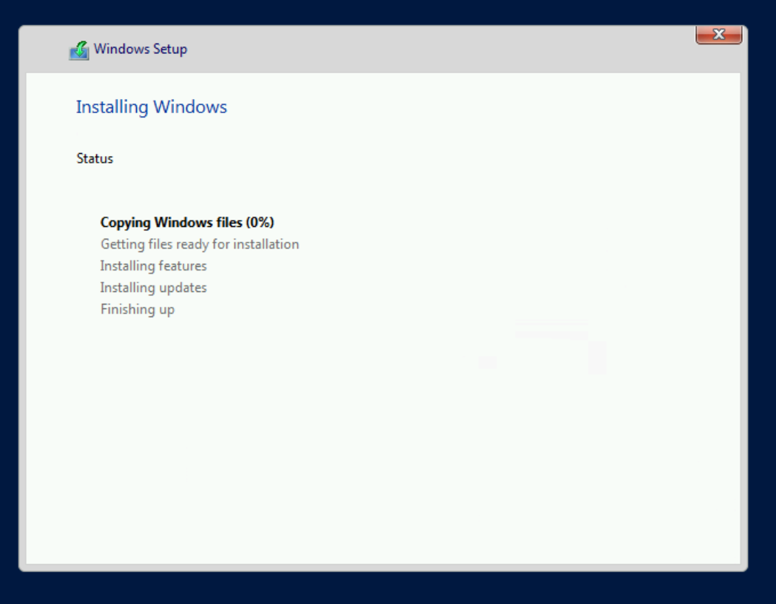

Figure 78 - Installing Windows

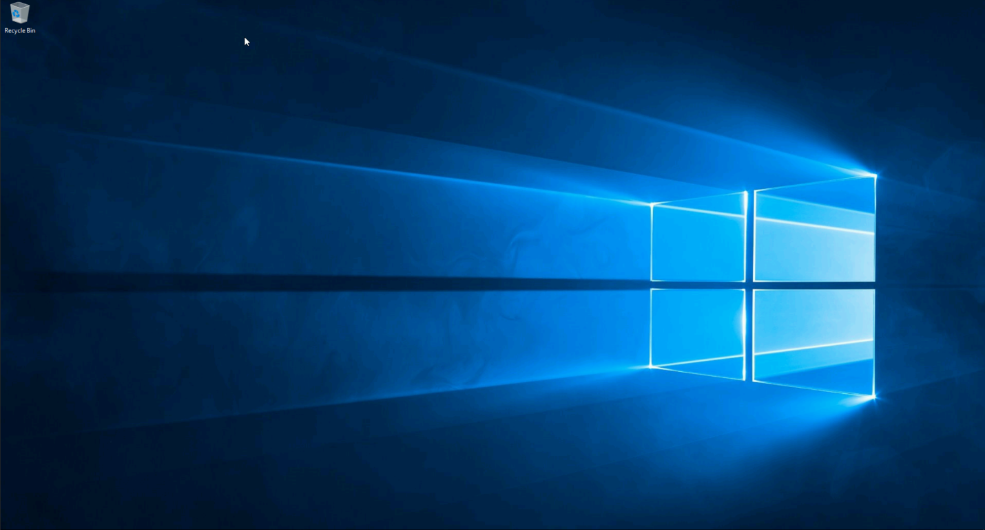

Figure 79 - The overview of the WS 2019 in Dell Server

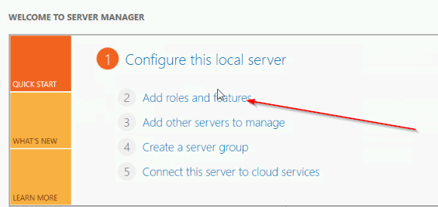

Figure 80 - Click "Add roles and features"

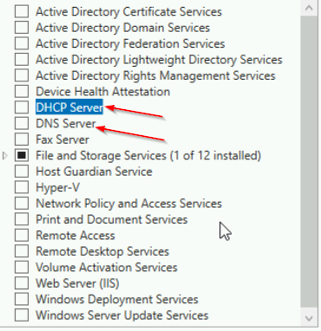

Figure 81 - Select DHCP and DNS Server

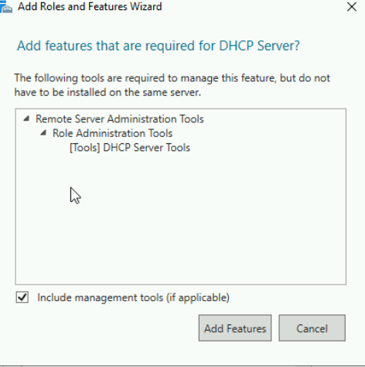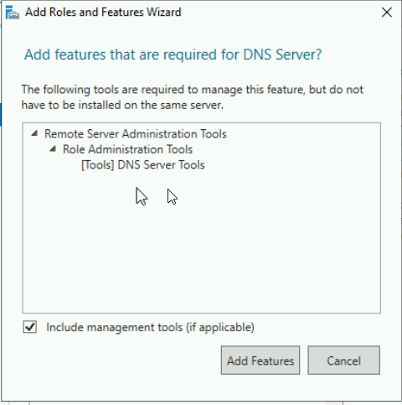

Figure 82 - Add Features for DHCP and DNS

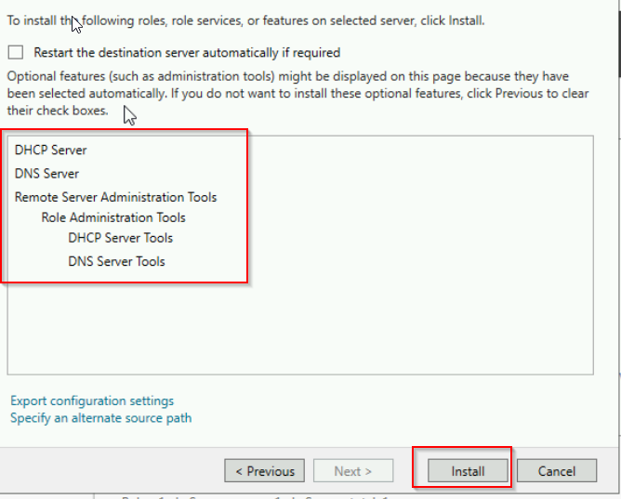

Figure 83 - Install both of it

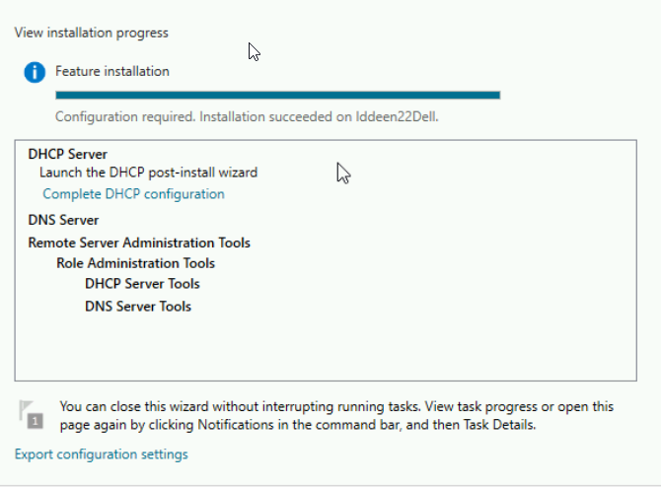

Figure 84 - Installation Completed

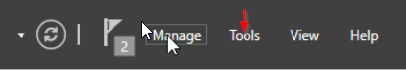

Figure 85 - Click "Tools"

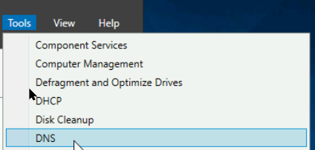

Figure 86 - Click "DNS"

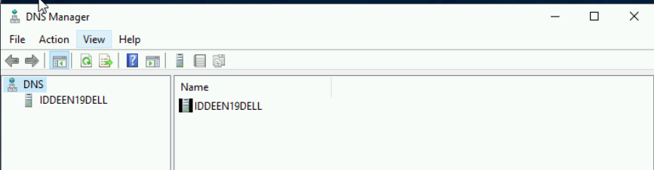

Figure 87 - See the overview of the DNS Manager

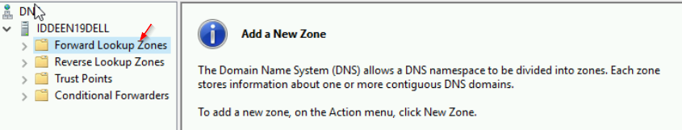

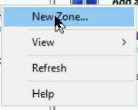

Figure 88 - Add a New Zone

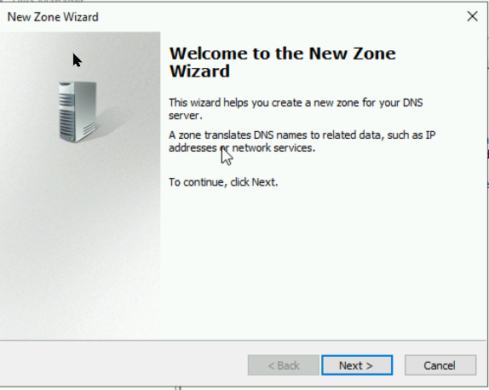

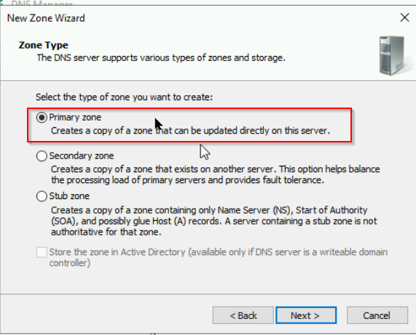

Figure 89 - Procced the Zone Wizard

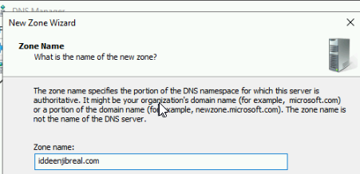

Figure 90 - Type the required text on Zone name

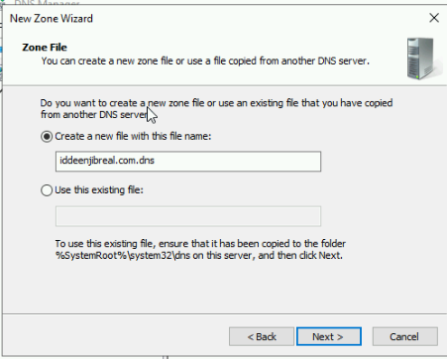

Figure 91 - Create a new file with this file name

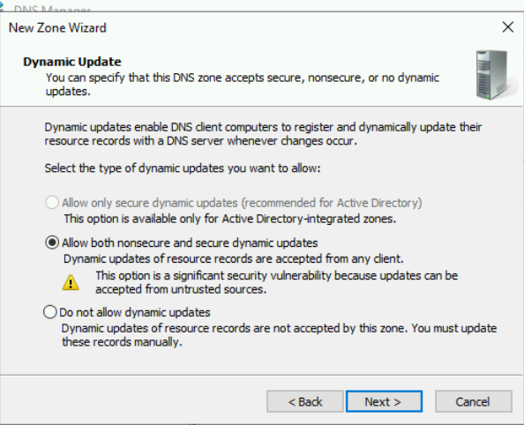

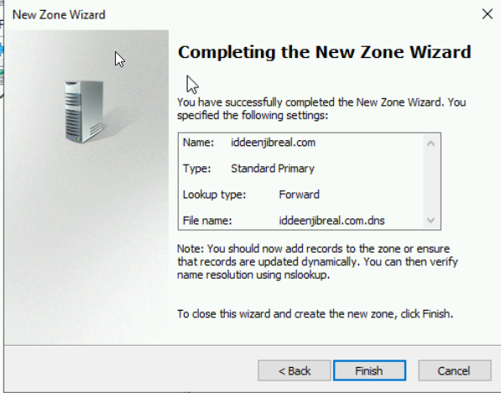

Figure 92 - Procced to complete the new Zone Wizard

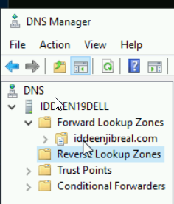

Figure 93 - Click "Reverse Lookup Zones" to create another zone

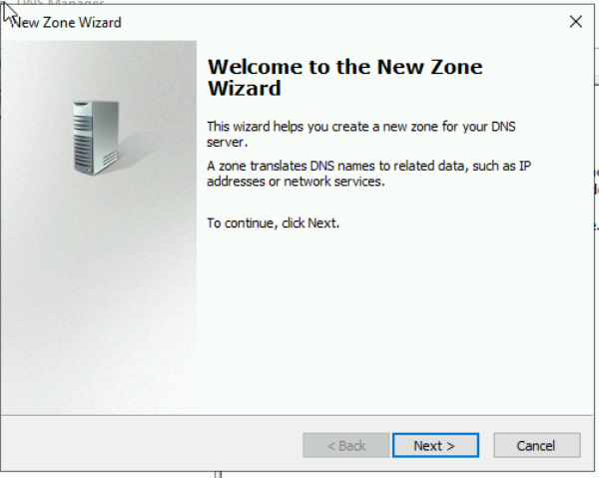

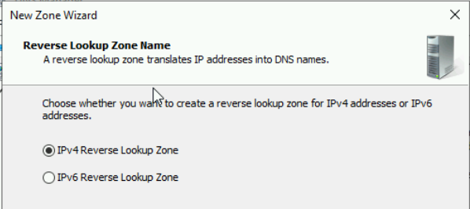

Figure 94 - Procced until click "IPv4 Reverse Lookup Zone”

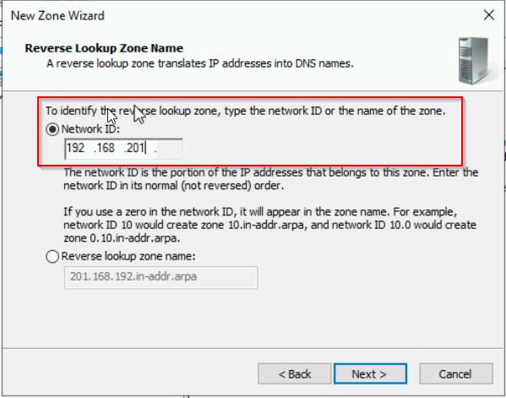

Figure 95 - Type the required network ID to procced

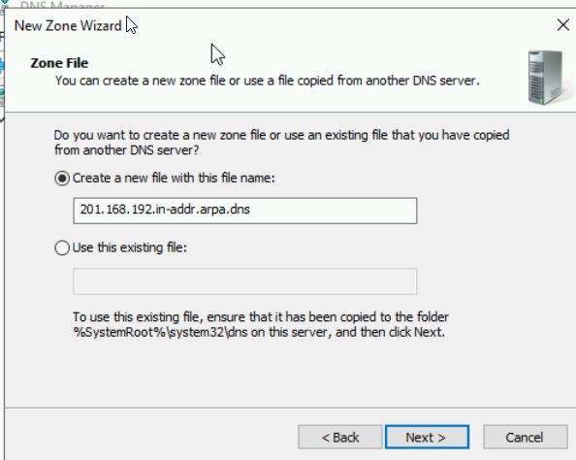

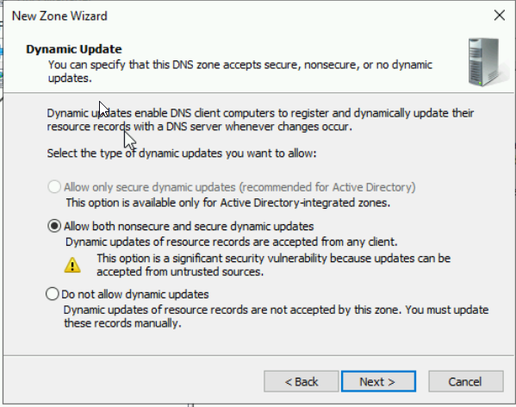

Figure 96 - Procced to do the same thing as for forward zone

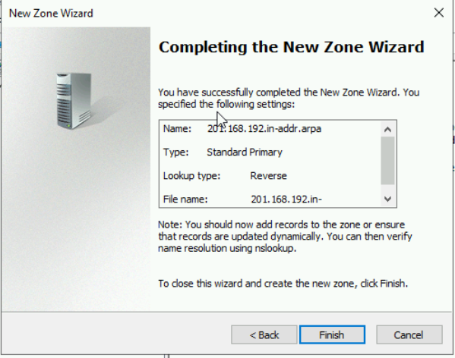

Figure 97 - Click "finish"

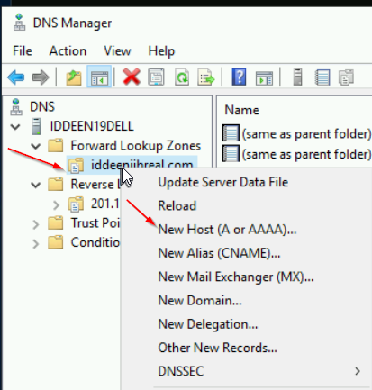

Figure 98 - Click "New Host (A or AAAA)"

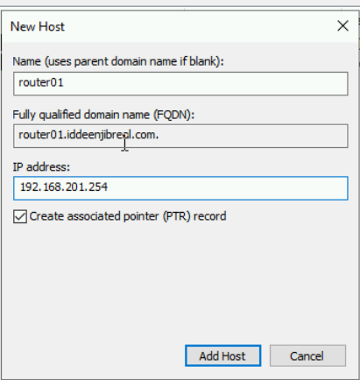

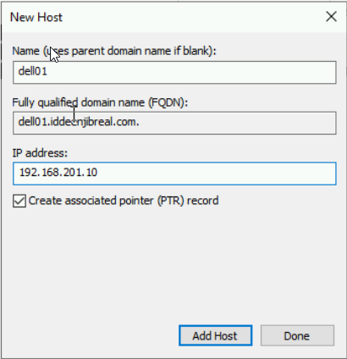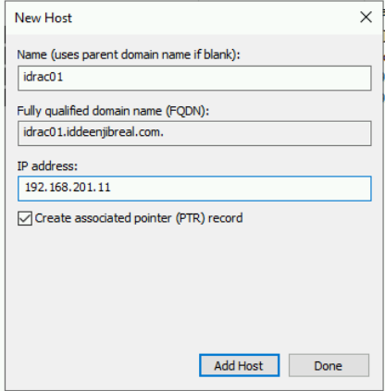

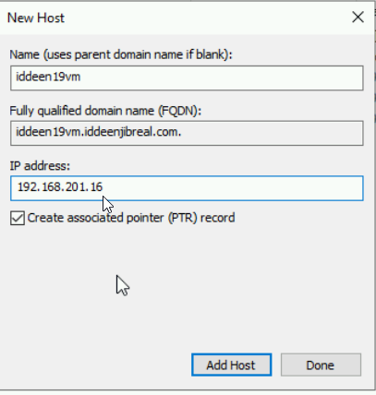

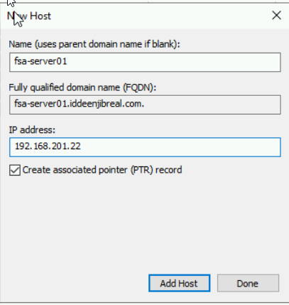

Figure 99 - Assign DNS A record for all of the devices



Figure 100 - Go back to the dashboard, and click "Tools"

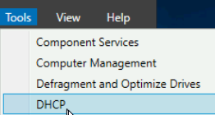

Figure 101 - Click "DHCP"

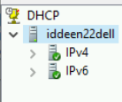

Figure 102 - See the overview of the DHCP menu

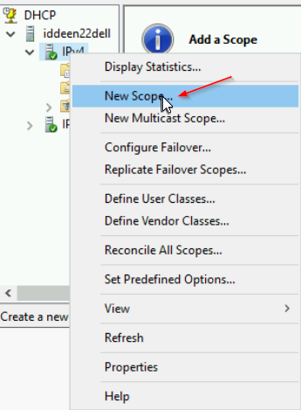

Figure 103 - Click "new Scope"

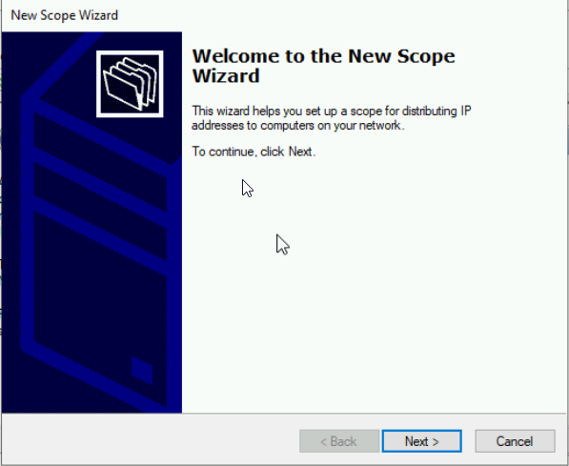

Figure 104 - "Click Next"

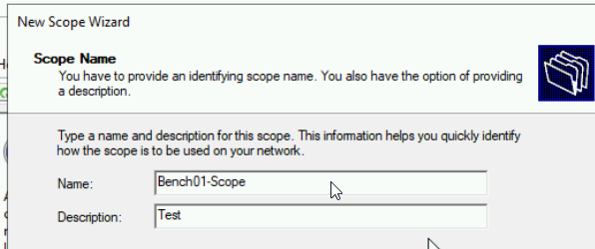

Figure 105 – Procced

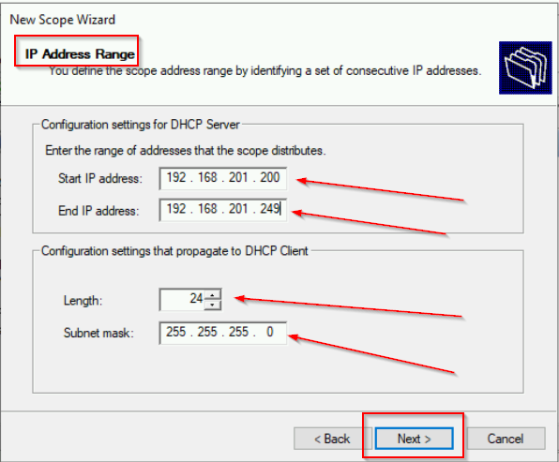

Figure 106 - Put the starting IP Address and the end to click "Next"

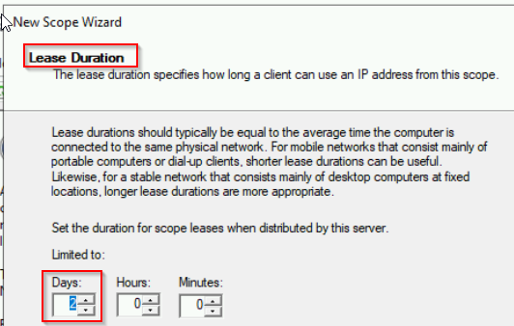

Figure 107 - set the Lease duration

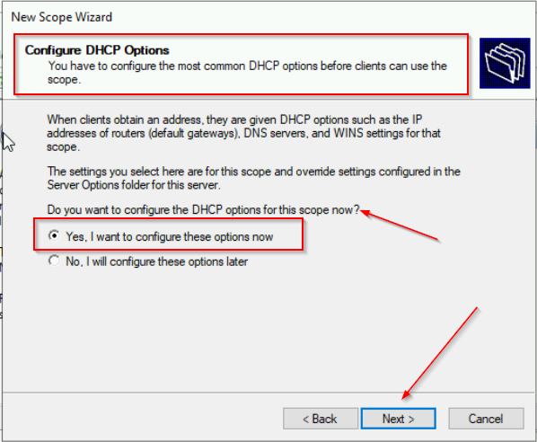

Figure 108 - Configure DHCP Options

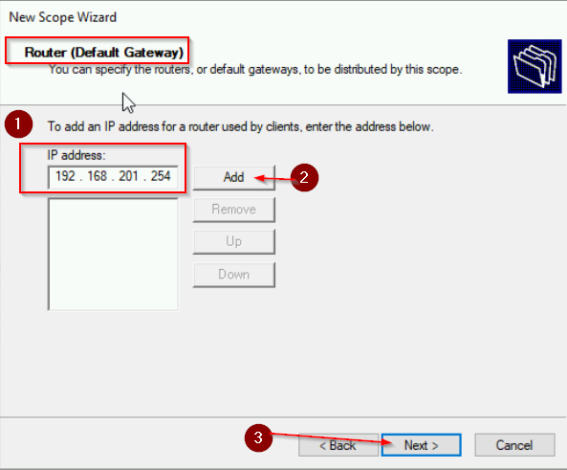

Figure 109 - Add the router Default Gateway

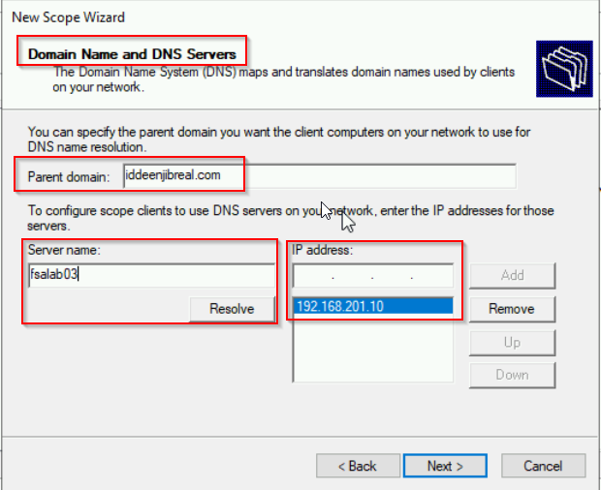

Figure 110 - Set the parent domain and edit the stuff, then click "next"

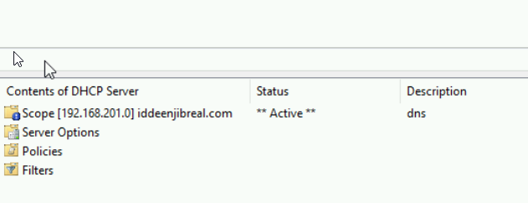

Figure 111 - See the Scope being Active!

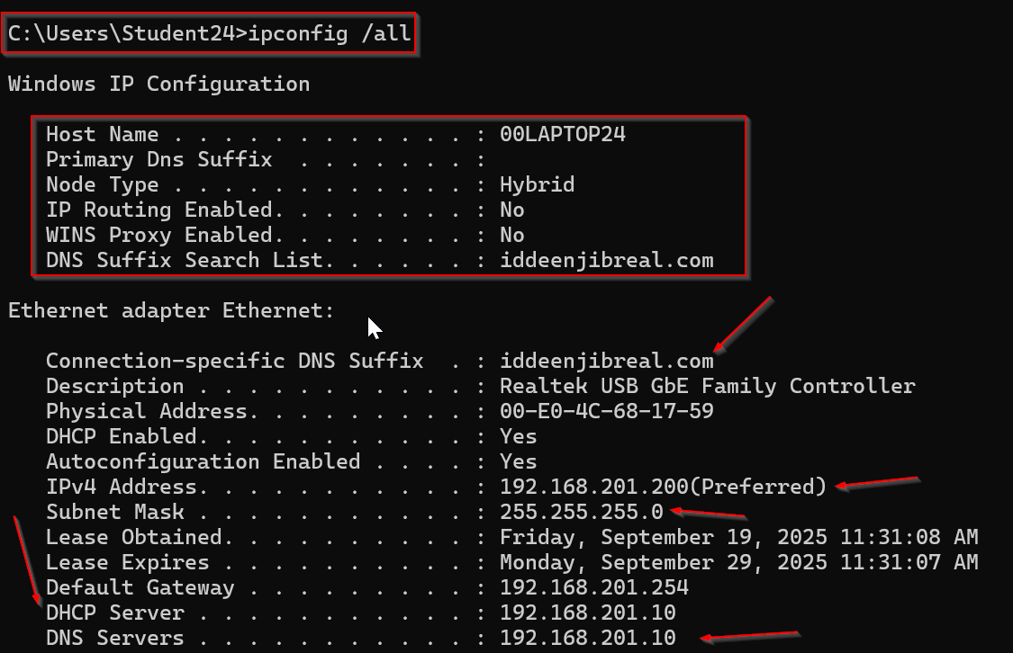

Figure 112 - See the laptop getting IP Address from DHCP Server

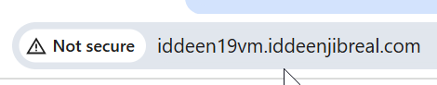

Figure 113 - Type the IIS website on laptop

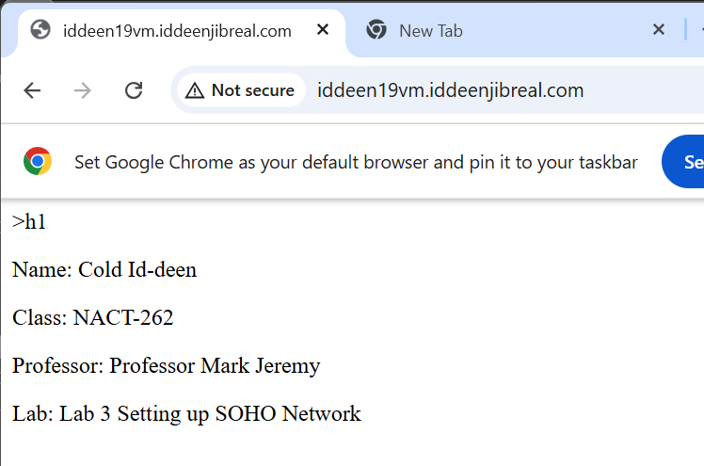

Figure 114 - See your own IIS website from the PCA

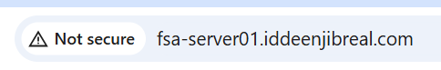

Figure 115 - Type another IIS website on the laptop

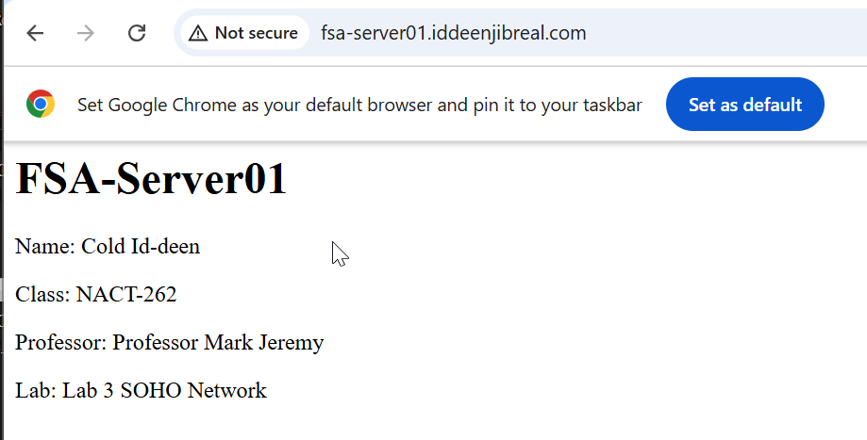

Figure 116 - See your own IIS Website from the PCB Core!

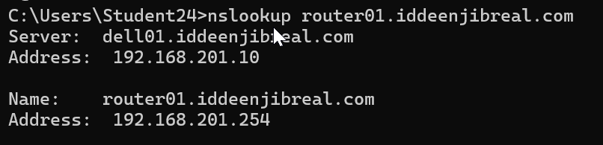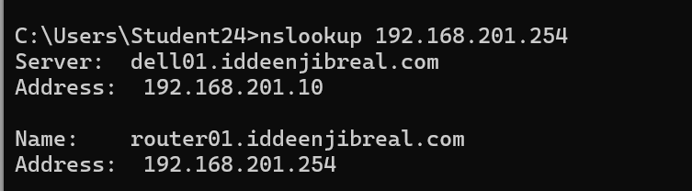

Figure 117- nslookup on DNS A and reverse IP records for router

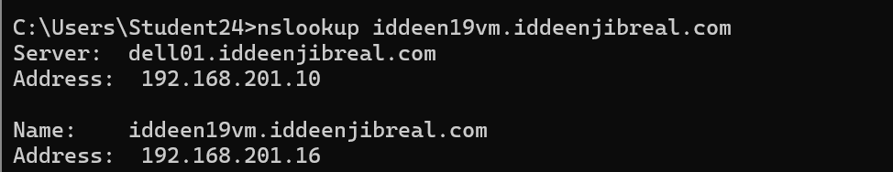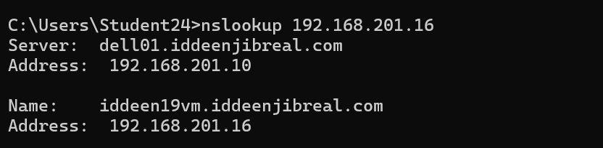

Figure 118 - nslookup on DNS A and reverse IP records for PCA VM

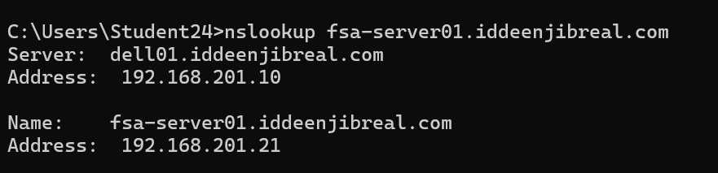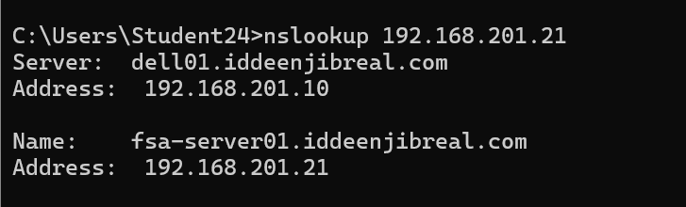

Figure 119 - nslookup on DNS A and reverse IP records for PCB Core

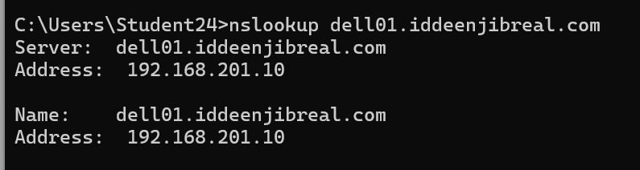

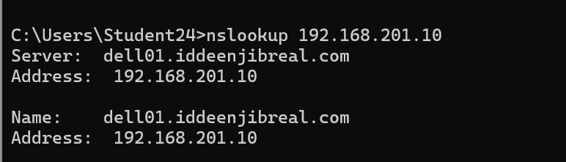

Figure 120 - nslookup on DNS A and Reverse IP records for Dell Server

### Questions and Answers

* In which part of the lab activity did you find the most challenging?
* Getting the VM truly bridged to the wired LAN while chasing the rogue router DHCP and fixing DNS/forwarders was the most painful part I struggled with.

### Observations

Well, it was excellent learning for me to do this type of stuff, it was really cool. I made big mistake that I added the “Excluded and Delay” to block any incoming DHCP IP Address while it was not supposed to happen! Good experience.